Topic Title (Verb + Subject, also enter in Metadata)

Overview
This is a step-by-step guide for journal entry. Once the entry is submitted, there is a review process.
This guide does not cover _Y_. If you need guidance on _Y_ use the instruction guide for _Y_.
The security roles for this process are ____. The required training for this process is ____.
Navigate to URL ADDRESS.

Heading (How to + Topic Title)
- Select the calendar icon beside the Journal Date field.
- Enter the correct date.
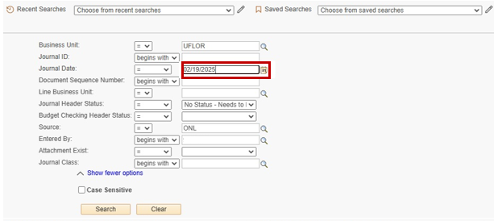

Note: The journal entry deadline is three business days before the last business day of the month to allow time for processing and review.
- Select Search at the bottom of the page.

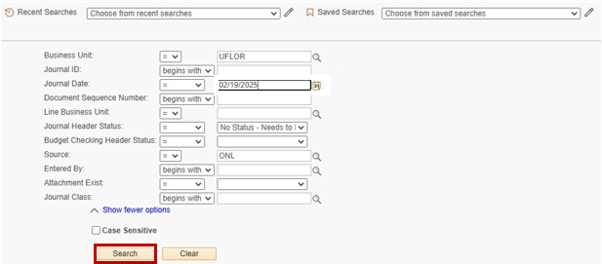

Travel Approvals by Month
Month | Pending | Approved | Denied
January | 5 | 15 | 3
February | 7 | 20 | 2
March | 4 | 25 | 1
April | 6 | 18 | 5
May | 8 | 22 | 4

Heading
- Bullet 1
- Bullet 2

For Additional Assistance
Technical Issues  UF Computing Help Desk  352-292-HELP  helpdesk.ufl.edu | Policies and Directives  {Office}  {Phone}  {Website}

Note: This is a nice way to set up this paragraph.

